**The Ark Documentation.**

**Add new subject: subject biospecimen.**

Once you have seen the confirmation message that the new subject has been created, you can proceed to add additional information.

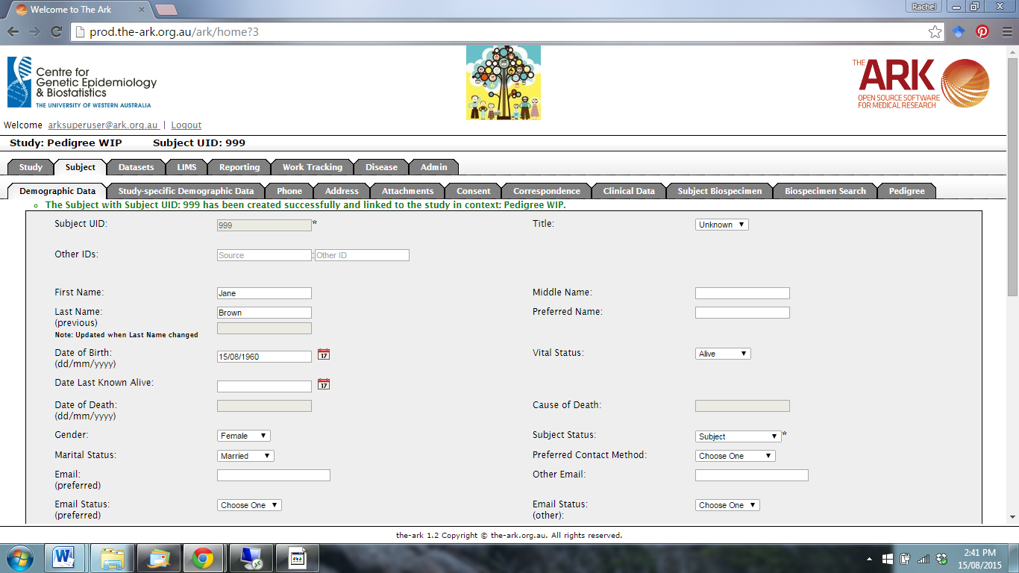

Click on the Subject Biospecimen function.

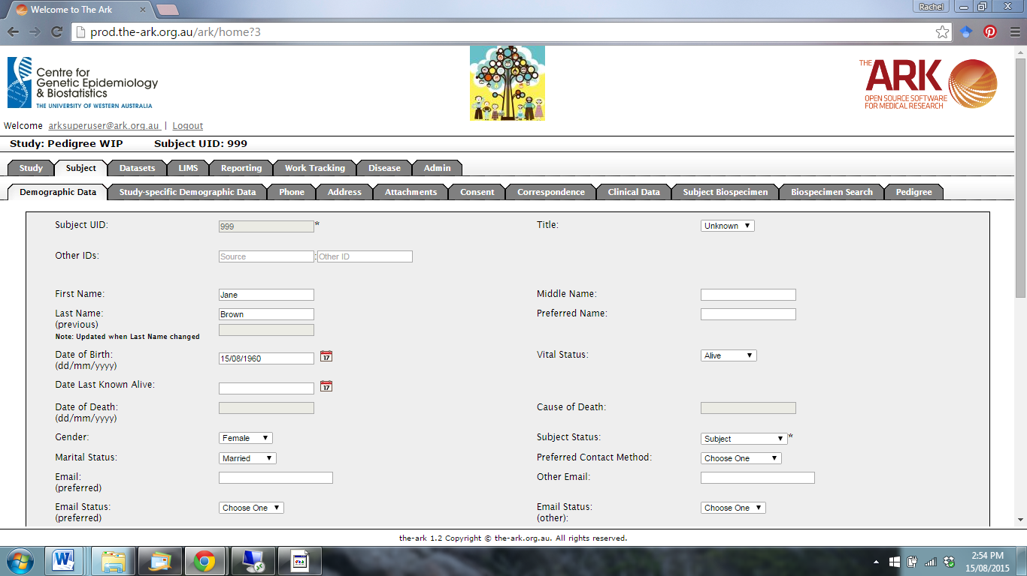

The following page will appear.

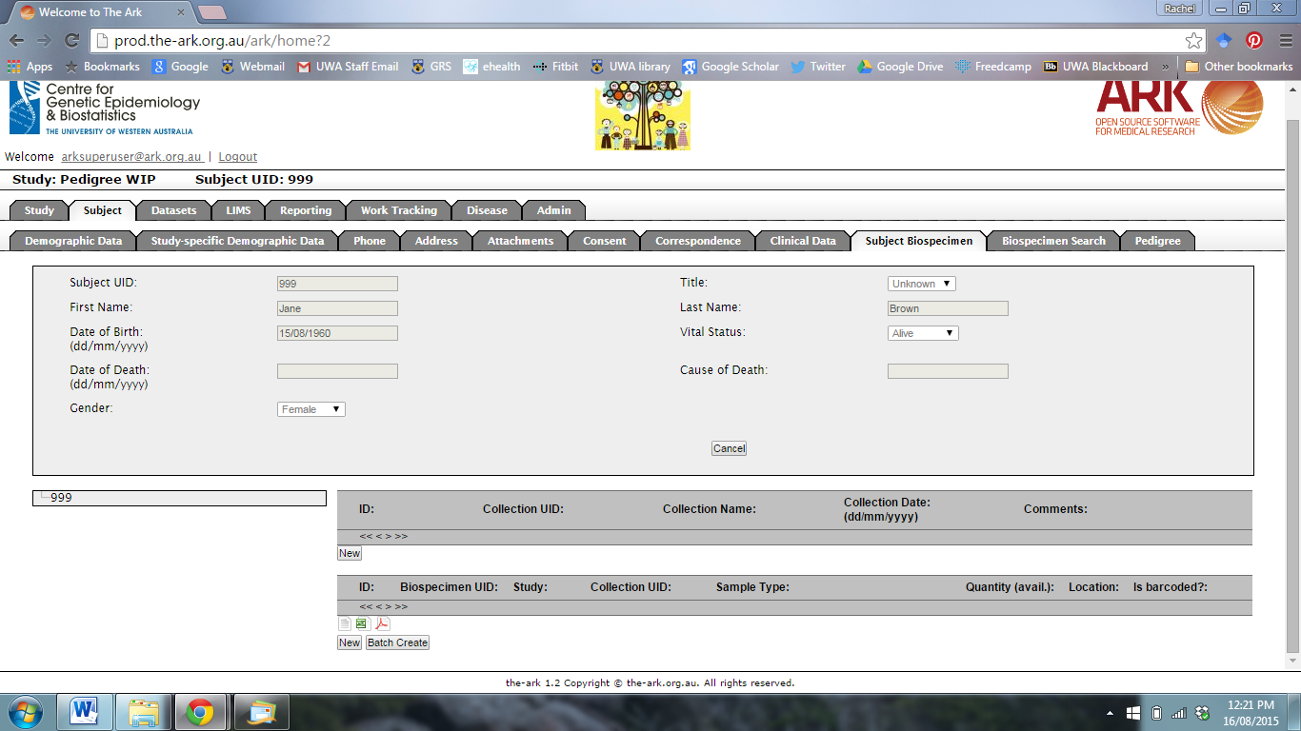

To add a new specimen Collection, click New.



The following page will appear.

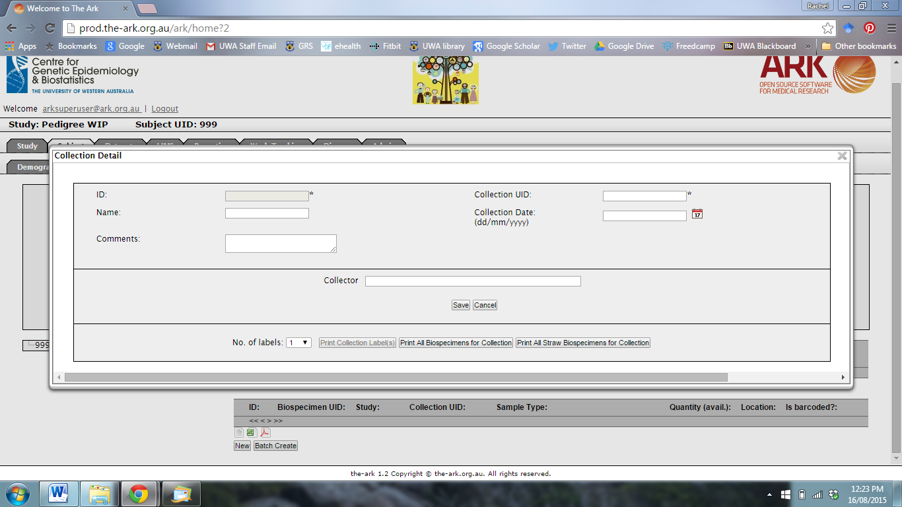

Add in the required information for the subject’s biospecimen collection using the comment boxes and calendar function.

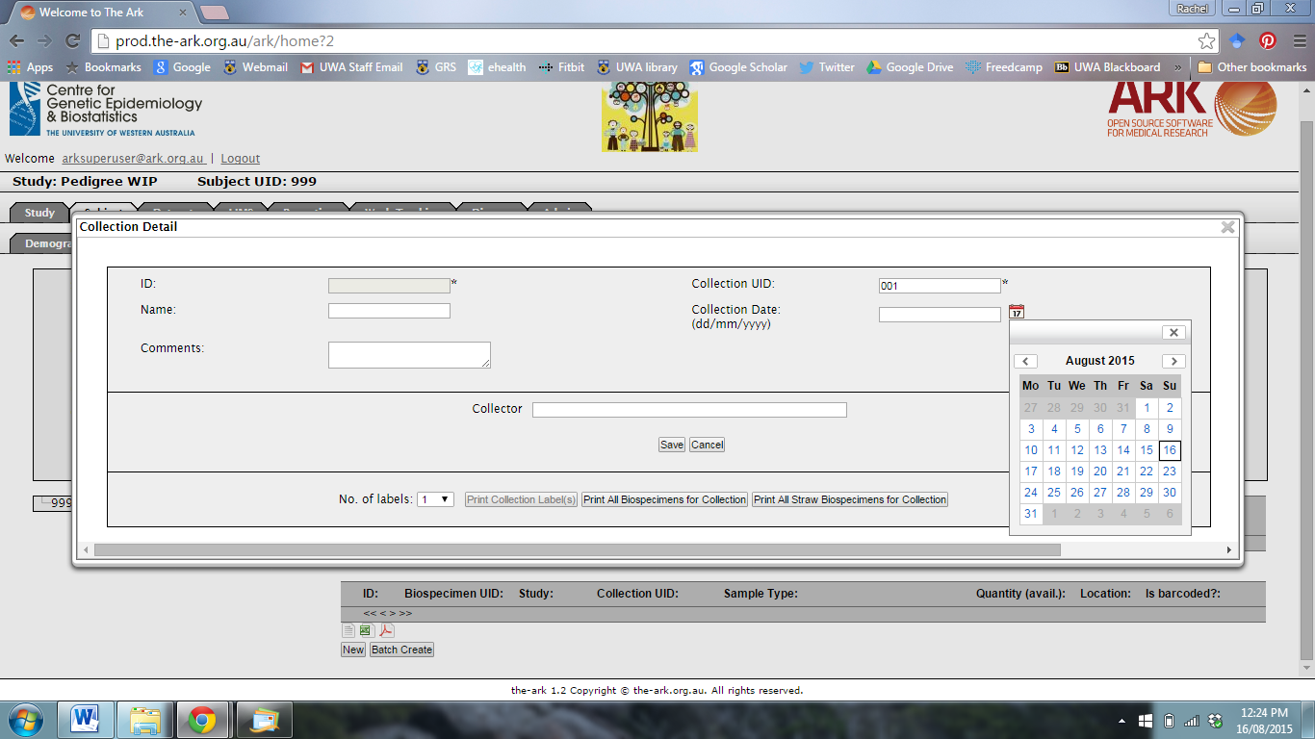

When you are finished, click Save.

You will see a collection has been created. You can now exit and return to the Subject Biospecimen Function.

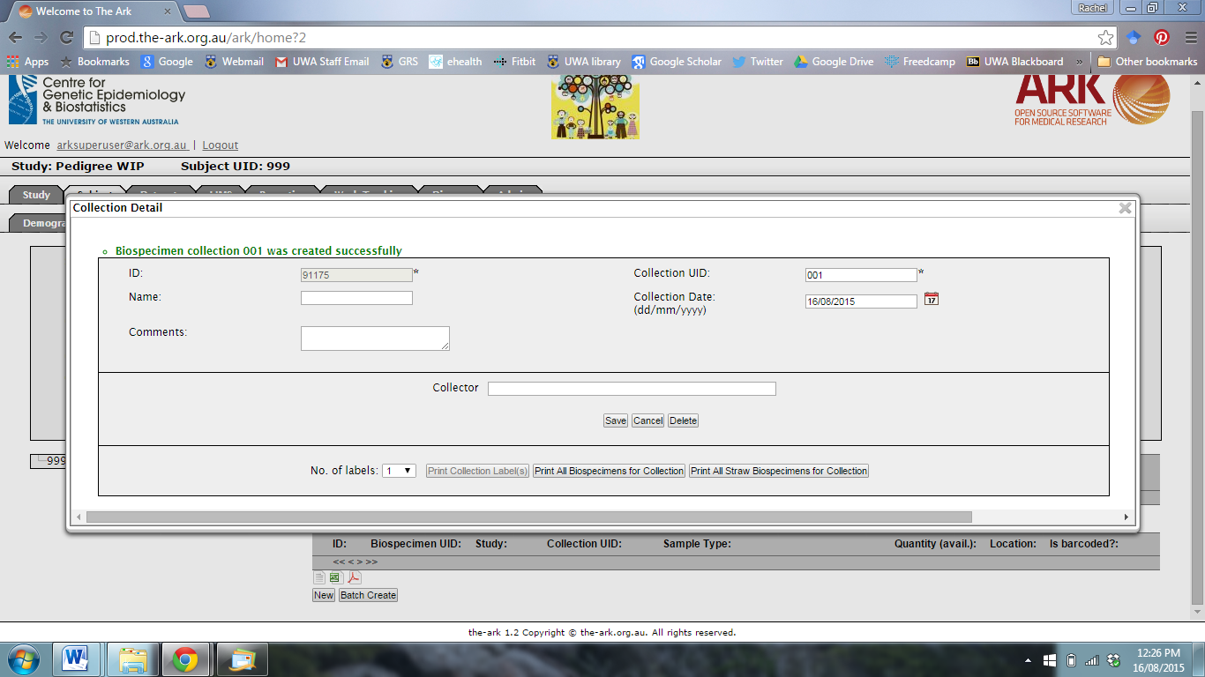

You will now see a new collection entry. You can click on the Collection UID to edit at any time, or to print labels.

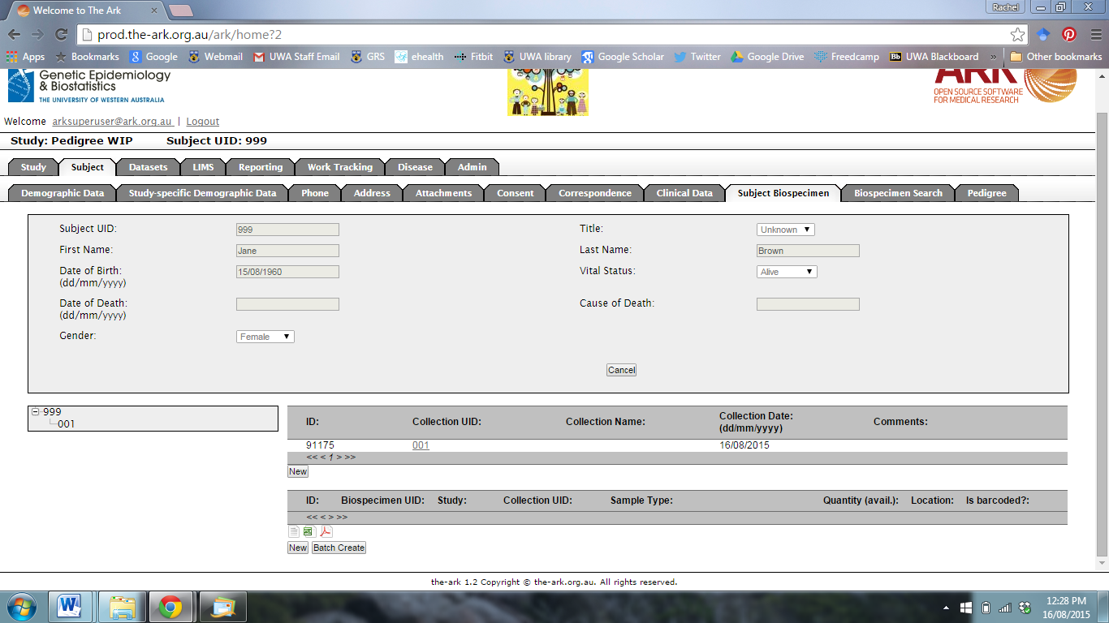

To add Biospecimens to the collection, click on New.



The following page will appear.

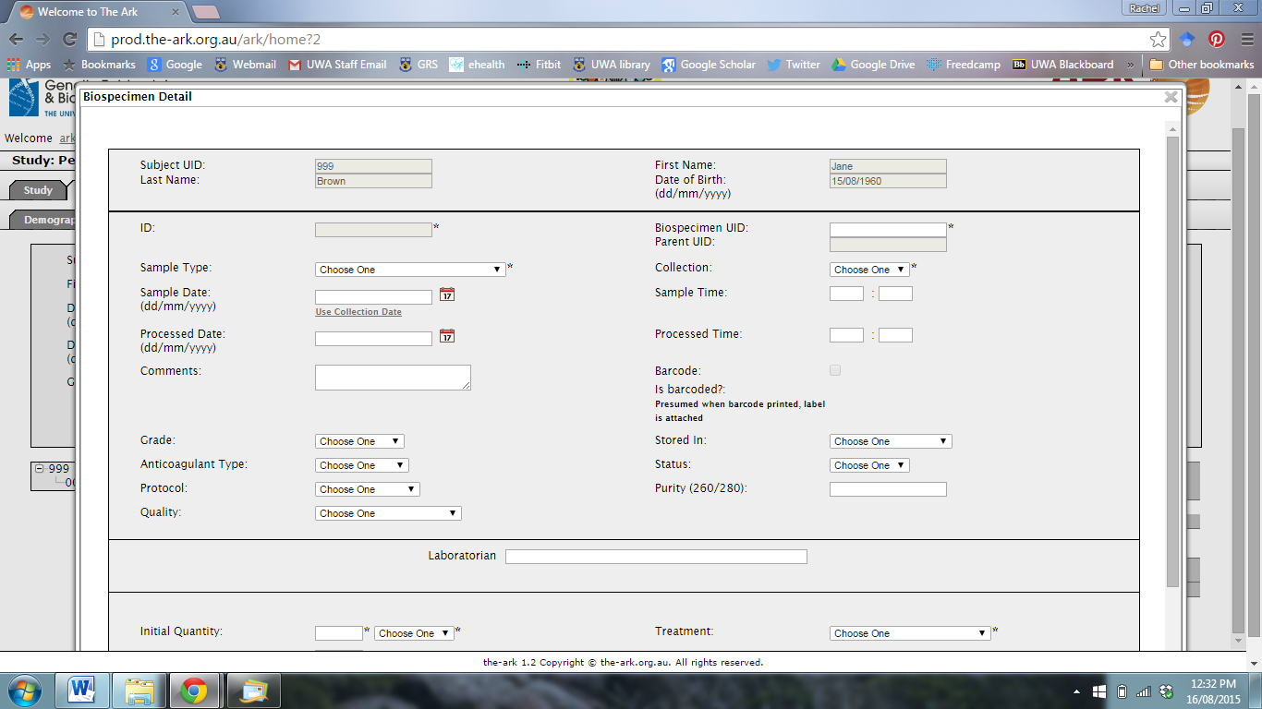

Enter a biospecimen UID.



Select a sample type from the drop-down menu.

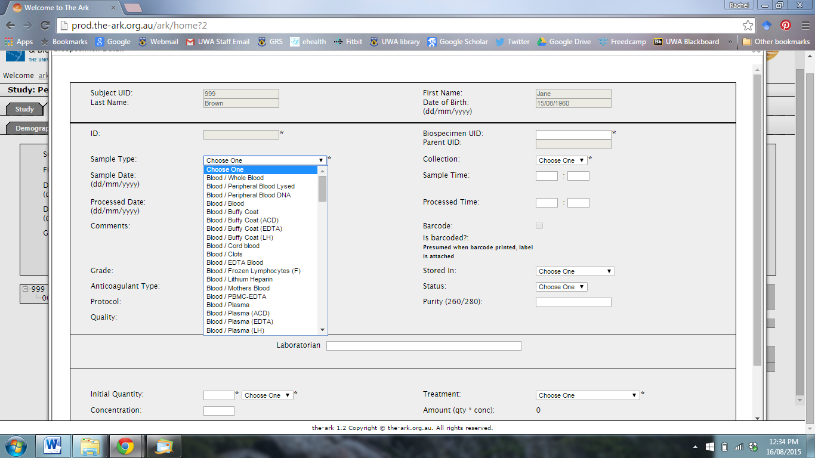

Add the biospecimen to a collection.

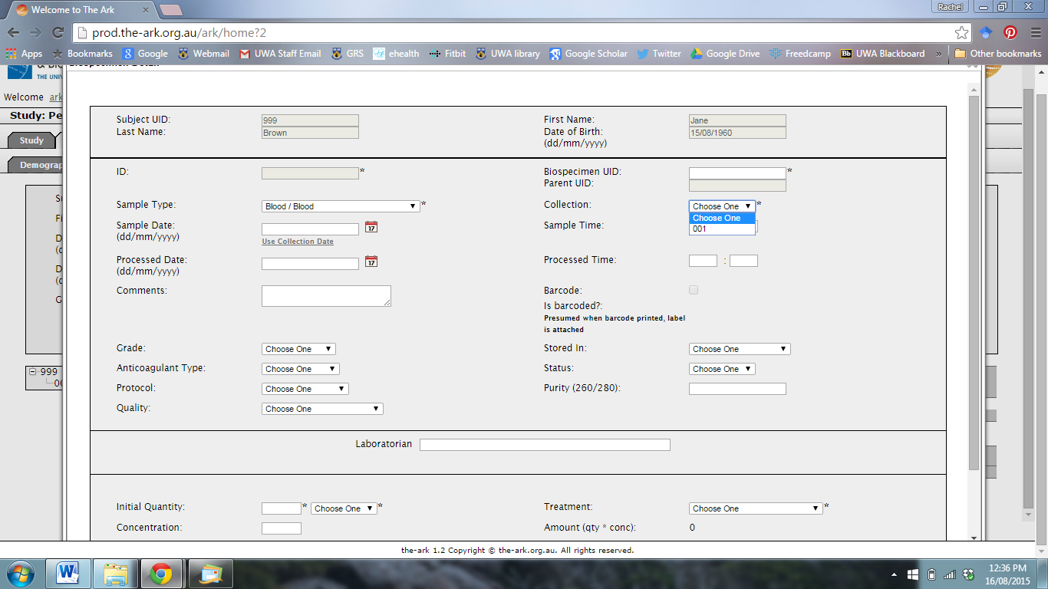

Enter additional information for the biospecimen using the drop-down menus and comment boxes.

Quantities can be added at the bottom of the page, and units can be selected using the drop-down menu.

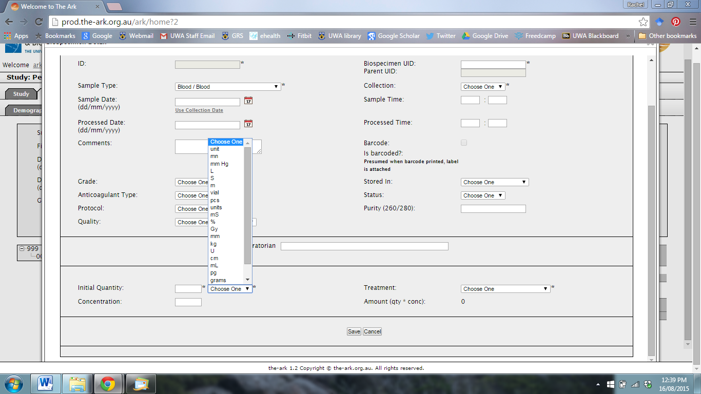

How the sample will be stored can also be selected using the Treatment menu.

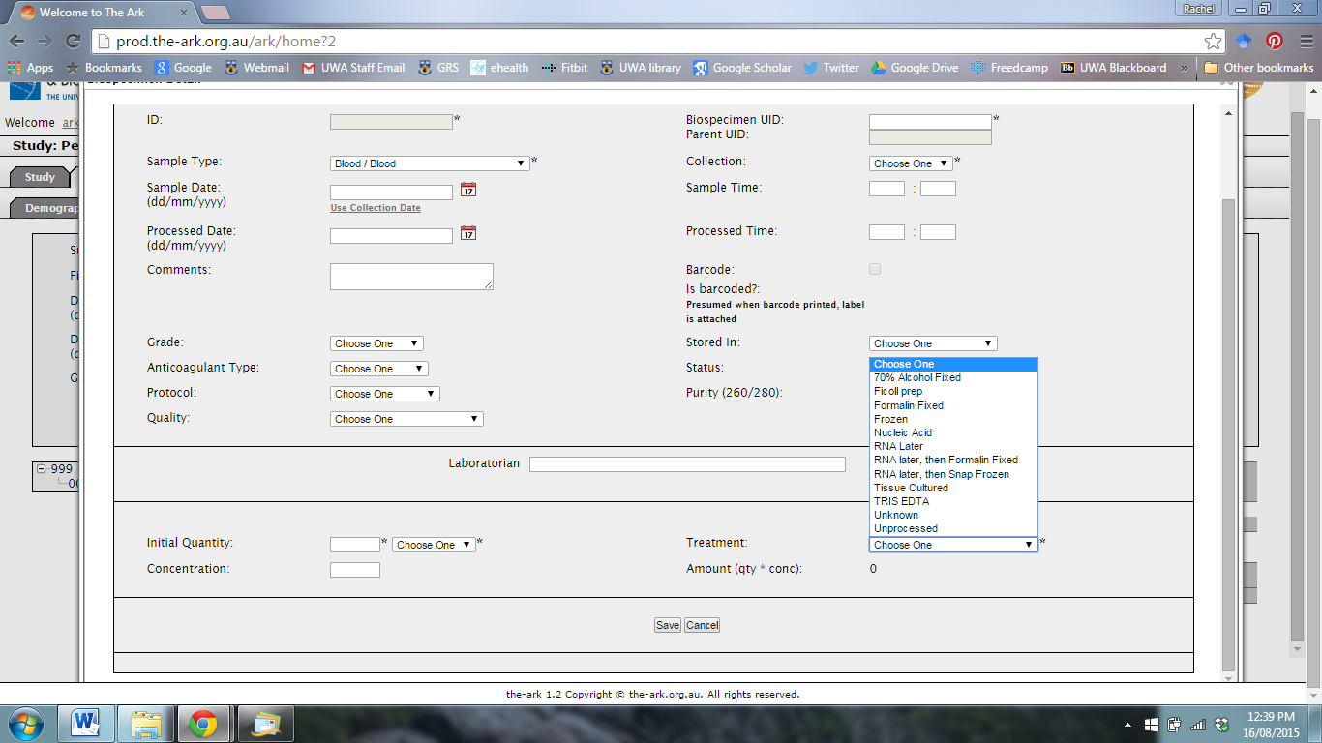

When you are finished, click Save.

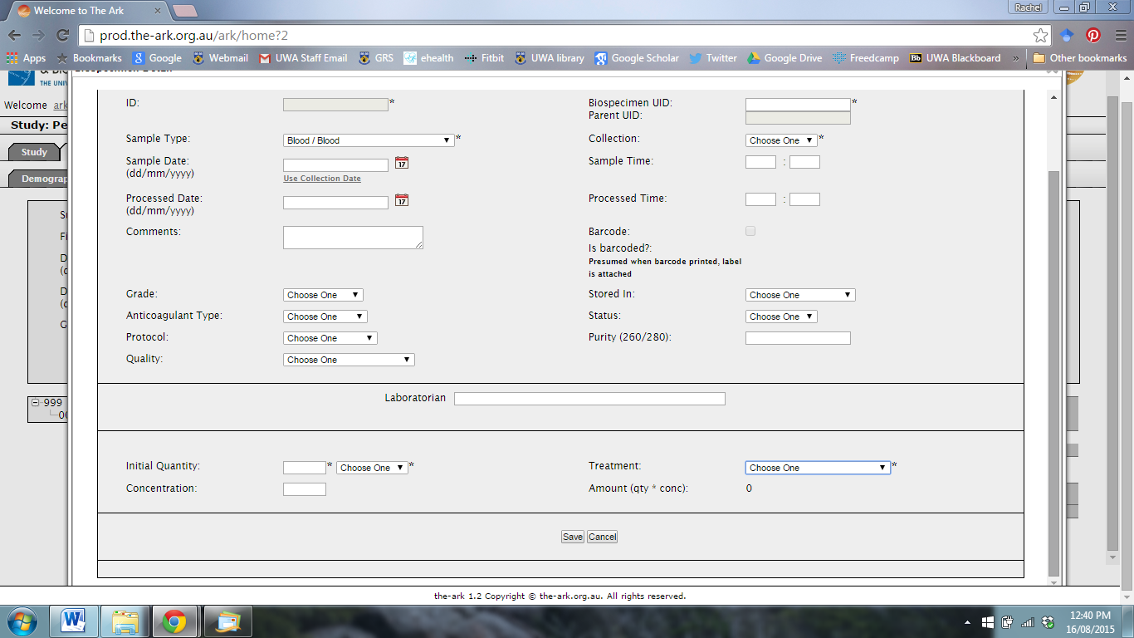

Note: you must enter all fields marked with an asterisk.

You will see that a new biospecimen has been created. You can now exit and return to the Subject Biospecimen Function.

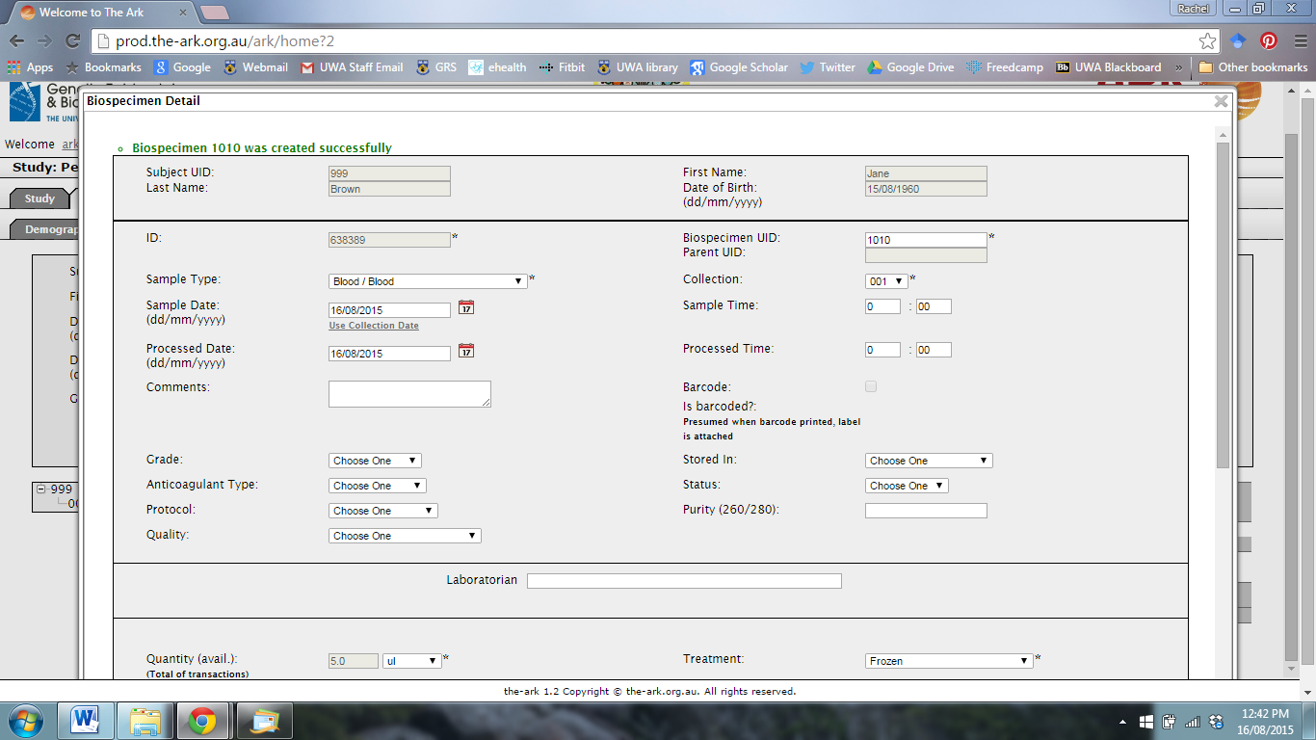

To clone, process or aliquot the biospecimen, use the options at the bottom of the screen when you re-enter the biospecimen page. Use clone to make an identical biospecimen with a unique Biospecimen ID.

